Case Study 1.7: When the loop dies: Getting on with MDI . V 1.3
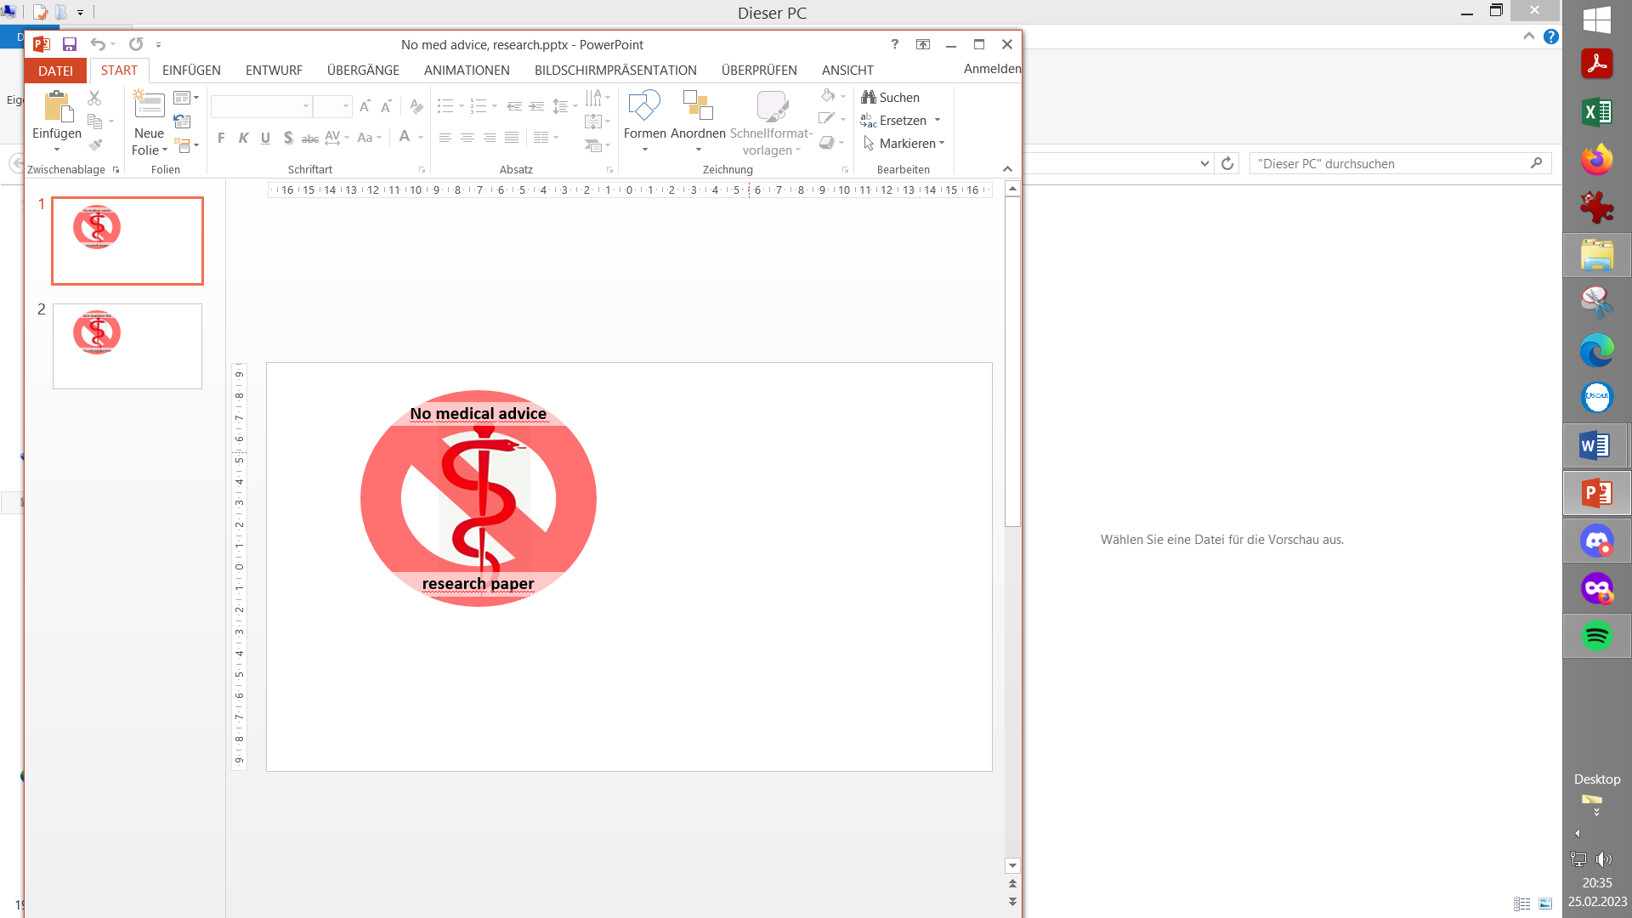

This case study reports a user experience in a 20 day period of having
no access to a closed loop (due to a broken AAPS compatible pump).

Data were collected in Nightscout after a Combo E7 error (pump break-down) at the end of a Spain vacation

Method
Adult on Lyumjev , TDD ~ 37 U of which 17 U profile basal; ISF ~ 30 mg/dl/U; IC ~ 8 g/ U
- Full Closed Loop ( FCL = no bolusing and no carb inputs by the user): 2x G6; Combo pump; AAPS/autoISF 3.2.0.4/3.0.1

- Bolusing for meals and for corrections; 15 of 20 days using an old pump to give profile basal. Virtual Pump mode in AAPS (Open Loop, entering insulin boli, and estimating carbs; “ MDI+ ”)

Results with Method B: Bolusing with pen + AAPS in Virtual Pump setting ( MDI+ )
20 days (17 Oct – 05 Nov. 2025) , mostly at home, without closed loop (after Combo E7 break-down).
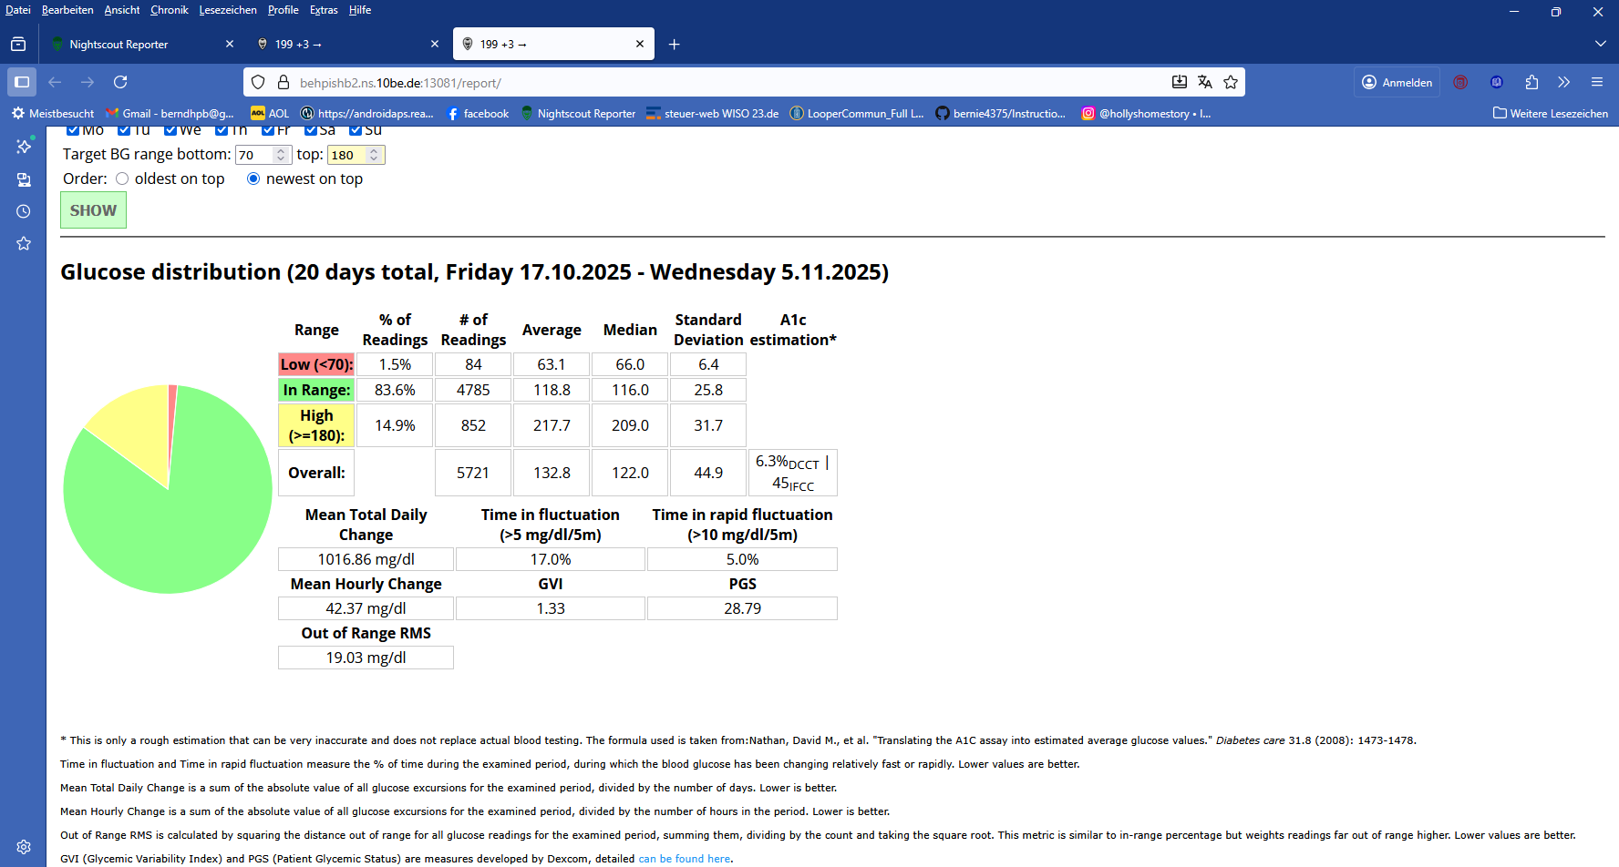

TIR percentile chart 20 days wiithout closed loop:
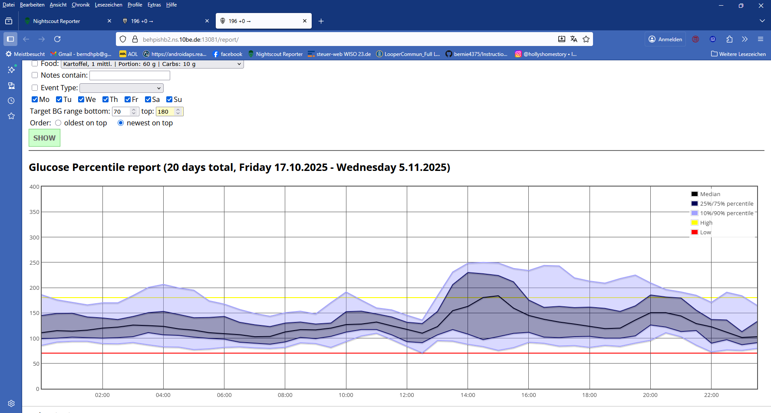

MIN and MAX daily glucose values
20 days wiithout closed loop:
 | Date |  |  |  |  | Min | Max
 | Wednesday 5.11.2025 |  |  |  |  | 64 | 204
 | Tuesday 4.11.2025 |  |  |  |  | 62 | 235
 | Monday 3.11.2025 |  |  |  |  | 49 | 301
 | Sunday 2.11.2025 |  |  |  |  | 56 | 185
 | Saturday 1.11.2025 |  |  |  |  | 56 | 166
 | Friday 31.10.2025 |  |  |  |  | 76 | 212
 | Thursday 30.10.2025 |  |  |  |  | 57 | 226
 | Wednesday 29.10.2025 |  |  |  |  | 81 | 169
 | Tuesday 28.10.2025 |  |  |  |  | 71 | 242
 | Monday 27.10.2025 |  |  |  |  | 66 | 320
 | Sunday 26.10.2025 |  |  |  |  | 72 | 269
 | Saturday 25.10.2025 |  |  |  |  | 68 | 237
 | Friday 24.10.2025 |  |  |  |  | 39 | 268
 | Thursday 23.10.2025 |  |  |  |  | 63 | 277
 | Wednesday 22.10.2025 |  |  |  |  | 77 | 188
 | Tuesday 21.10.2025 |  |  |  |  | 67 | 176
 | Monday 20.10.2025 |  |  |  |  | 50 | 229
 | Sunday 19.10.2025 |  |  |  |  | 55 | 173
 | Saturday 18.10.2025 |  |  |  |  | 70 | 275
 | Friday 17.10.2025 |  |  |  |  | 59 | 291
< 60 or > 250 8 / 20 7 / 20

Results with Method A (AAPS Full Closed Loop, FCL)
20 prior days in Full Closed Loop (half of which in Spain vacation)
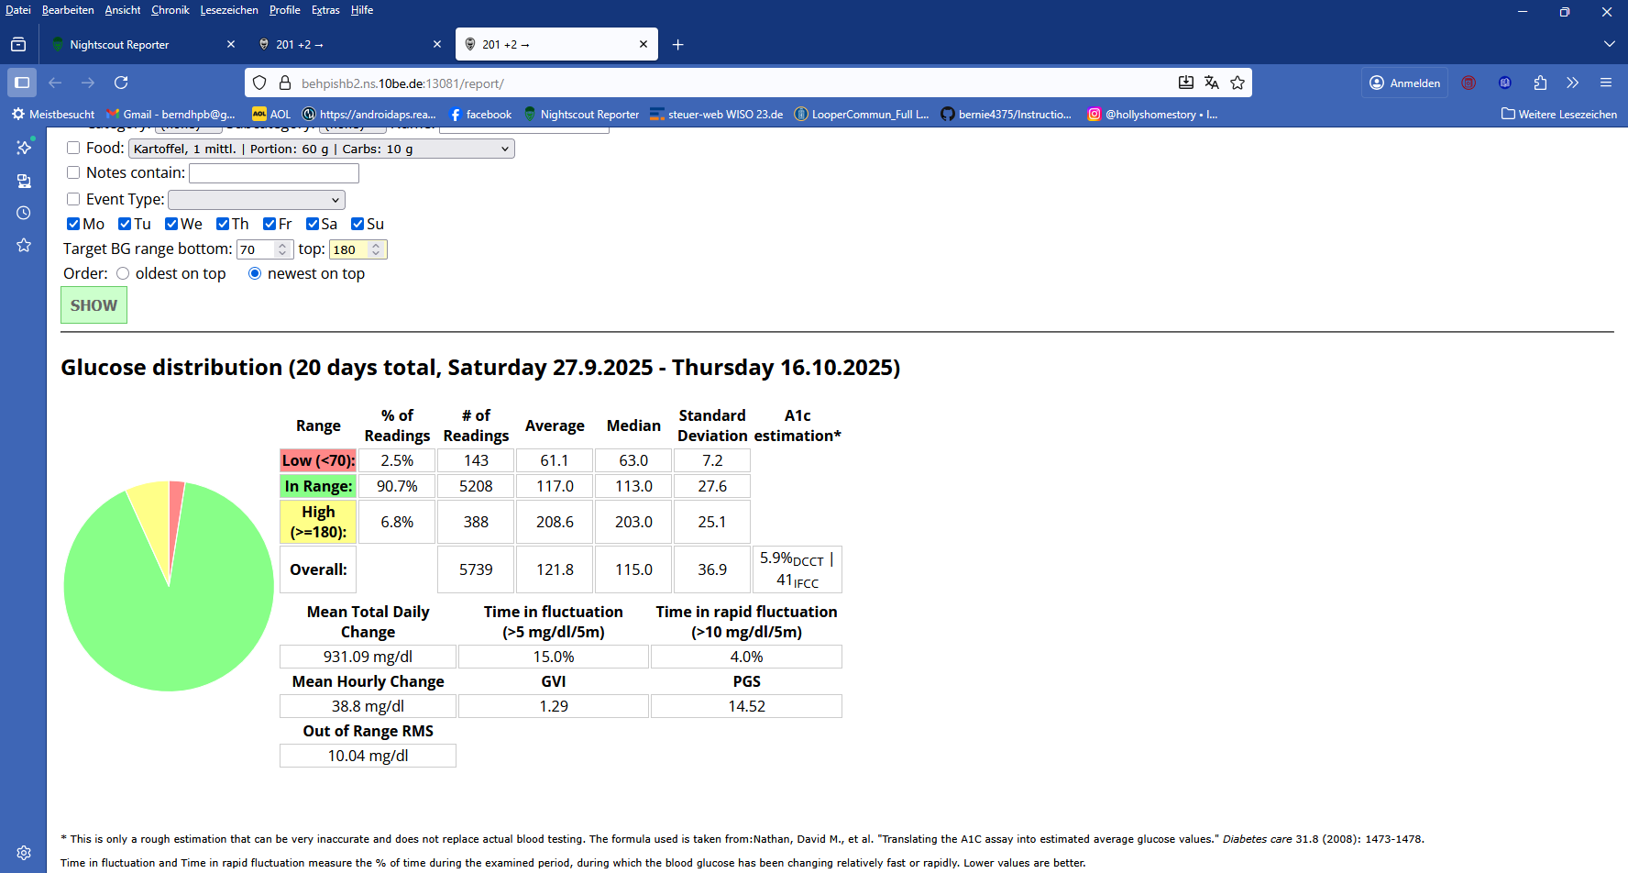
The Full Closed Loop period included 8 vacation days => a bit more challenging for the FCL
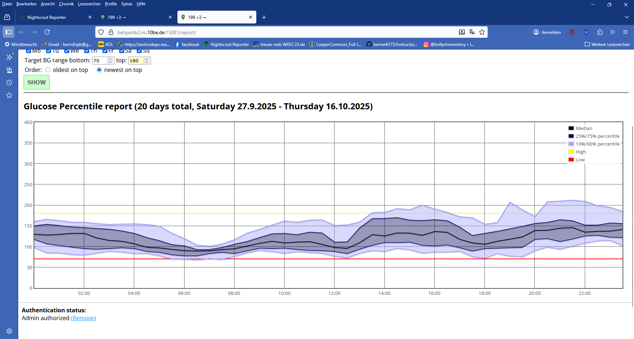

MIN and MAX daily glucose values
 | Thursday 16.10.2025 |  |  |  |  | 60 | 235
 | Wednesday 15.10.2025 |  |  |  |  | 69 | 221
 | Tuesday 14.10.2025 |  |  |  |  | 59 | 271
 | Monday 13.10.2025 |  |  |  |  | 72 | 196
 | Sunday 12.10.2025 |  |  |  |  | 70 | 211
 | Saturday 11.10.2025 |  |  |  |  | 75 | 227
 | Friday 10.10.2025 |  |  |  |  | 54 | 214
 | Thursday 9.10.2025 |  |  |  |  | 70 | 169
 | Wednesday 8.10.2025 |  |  |  |  | 70 | 154
 | Tuesday 7.10.2025 |  |  |  |  | 56 | 202
 | Monday 6.10.2025 |  |  |  |  | 90 | 230
 | Sunday 5.10.2025 |  |  |  |  | 56 | 221
 | Saturday 4.10.2025 |  |  |  |  | 70 | 219
 | Friday 3.10.2025 |  |  |  |  | 52 | 240
 | Thursday 2.10.2025 |  |  |  |  | 41 | 280
 | Wednesday 1.10.2025 |  |  |  |  | 39 | 184
 | Tuesday 30.9.2025 |  |  |  |  | 48 | 181
 | Monday 29.9.2025 |  |  |  |  | 56 | 177
 | Sunday 28.9.2025 |  |  |  |  | 51 | 185
 | Saturday 27.9.2025 |  |  |  |  | 56 | 185
< 60 or > 250 11 / 20 1 / 20

Discussion
This is a comparison of 20 days on a multiple daily injections (MDI+) strategy that was mostly guided by AAPS data in Virtual Pump / Open Loop mode, with 20 preceding days on autoISF Full Closed Loop (FCL).-
High bg values (post-prandial bg rises; roller-coasters)
MDI could actually be superior to FCL because of the following inherent principal advantages vs FCL:
1) Pre-bolusing for meals should limit post-prandial bg rises
2) Counting and entering carbs, plus inputting bolus information into AAPS, plus watching insulin activity curve vs est. carb digestion, should allow an experienced user to navigate quite well.
Indeed, 83.6 % TIR (HbA1c 6.3%) is probably an acceptable situation.
It is significantly worse, though, than what resulted in the 20 preceding days using FCL, showing 90.7 % TIR (HbA1c 5.9%). *)
*) This FCL period included vacation, 24/7 with friends, different meal and activity patterns than usual. The user’s long term average FCL TIR is 93-94%, with lower lab confirmed HbA1c, too.
So, what are the disadvantages of the MDI strategy vs. FCL leading to much higher number of values over 250 mg/dl?:
1) In daily life, navigating the bg cannot be done several times each hour (while the FCL can do it every 5 minutes).
2) Specifically, it is very difficult to manage meals with more than one bolus given, as usually required in MDI (and especially so when using a “fast” insulin.- Rough estimates (size, timing) for further bolusing after the initial meal bolus very often make the bg run low or high. This can be improved when using data visible in AAPS Open Loop / Virtual Pump mode. But nobody can consistently payi close attention for hours after each meal. That is an advantage that only the automatic management in Closed Loop achieves easily.
3) In MDI there is no night regulation, except alarms alerting for extremes. This results in a wide spread of values in the night data. In contrast, it is one of the easy achieved benefits of closed looping that the loop usually does an excellent job to provide bg in a narrow good range at the beginning of each day. See spread between 4 and 8 am in both Glucose Percentile reports).

Low bg values (under 60 mg/dl)
In FCL, there were 11 of 20 days with bg values under 60 mg/dl, while in MDI there was an incidence of 8 / 20 days.
This is not a worrisome result in FCL, where swinging low is always counter-regulated, meaning usually no user intervention is needed because it self-resolves.
The 8/20 days in MDI is more of a concern. It actually included events where a bg roller coaster had developed, and emergency fast carbs were required (and on going activities had to be interrupted) to prevent a dangerous hypo.

Conclusion
MDI+ performed inferior to FCL.

More remarks on (not) employed methods
“MDI+” vs MDI
Many years back the author had managed his T1D with classical MDI management, first with 2 types of insulin and pens plus a glucometer, later replacing the retard insulin with a pump to provide for the basal needs.
The advent of CGM systems was really not a decisive plus for quality of MDI treatment because it “invited” rash decisions, with ensuing roller-coasters.
Aside from trying to micromanage daily bg in MDI, CGMs did and do of course provide great benefits. For instance, just by periodically analyzing bg developments with the aid of a CGM will support behavior changes (eating, moving around…) that help improve bg curves . Likewise, CGMs are invaluable for determining the basal rate, especially the nightly one. And all Closed Loops absolutely rely on a good CGM 24/7.
Also the more rapid insulins that came to market did not really make a big positive difference for MDI. OK, they can help in case you forgot to bolus, or if you can’t pre-bolus because, in a restaurant, you have no control over when the food will actually arrive. But, if you properly pre-bolus, you might actually benefit from using a slow insulin because its activity matches better with carb absorption (digestion), and there is reduced need for second and third boli, which are typically hard to figure out in terms of both, size and timing. Incidence and severity of roller-coasters therefore might be reduced when using a “slower” insulin.
For a really improved MDI therapy (“ MDI+” ), the user must understand the sluggish nature of control. This is greatly, and in real-time, supported by employing AAPS in Virtual Pump/Open Loop mode (…which does require a good CGM). If the user inputs all the given insulin manually, the AAPS home screen displays the aggregate insulin activity from past bolusing, and even looks into the next hour or two. Carb decay can be realistically modelled, as well. Over time, the user learns, when and how to interfere for desired results – just by watching the curves develop, and also from “Open Loop” suggestions made by AAPS.

Would Hybrid Closed Loop (HCL) offer even better %TIR”?
Occasionally there is debate that, for the sake of making daily life easy, FCL gives up some performance. This sounds logical, as in absence of a manual pre-bolus, bg values tend to go up steeper right after meal start. So it could be a hypothesis that, if using HCL, even better %TIR performance would have been reached.
However, the few available studies all point in the direction that FCL and HCL give similar results (see e.g. the study quoted at. https://androidaps.readthedocs.io/en/latest/AdvancedOptions/FullClosedLoop.html#what-to-expect ). It seems that a well tuned-in FCL manages late meal phases with better results than a Hybrid Closed Loop that must pick up, as the user-given bolus fades out.

Limited value of studies in our field
Method comparisons are extremely difficult because they often suffer from problems like: * Methods differ in more than the investigated topic (e.g. FCL uses autoISF, HCL uses dynamicISF). * Length of experience, and tuning quality, differs between the methods * The true effect (how exactly the studied feature, and key tuning parameters, make a difference in the results seen) is not analyzed, only rather global result data are generated * The effects from technical failures (BT losses, false CGM values, occlusions/tunneling) are not analyzed in the reported results * Studied foods and lifestyle scenarios favor one method * Too short of an observation period to cancel out random effects.
Certainly, the n=1 report given above does not qualify as a study. It is an observational report that resulted, literally, quite by accident (losing the AAPS capable pump).

If reading reports and studies facilitates the readers’ ability and motivation to occasionally attempt deeper analysis of their own daily data, and try one new idea, that is probably the best use - especially if done interactively, inviting also feedback from others in the t1d communities (and from your doctor, if she/he has the time…)..

